Dandenong Agricultural & Pastoral Society Inc.

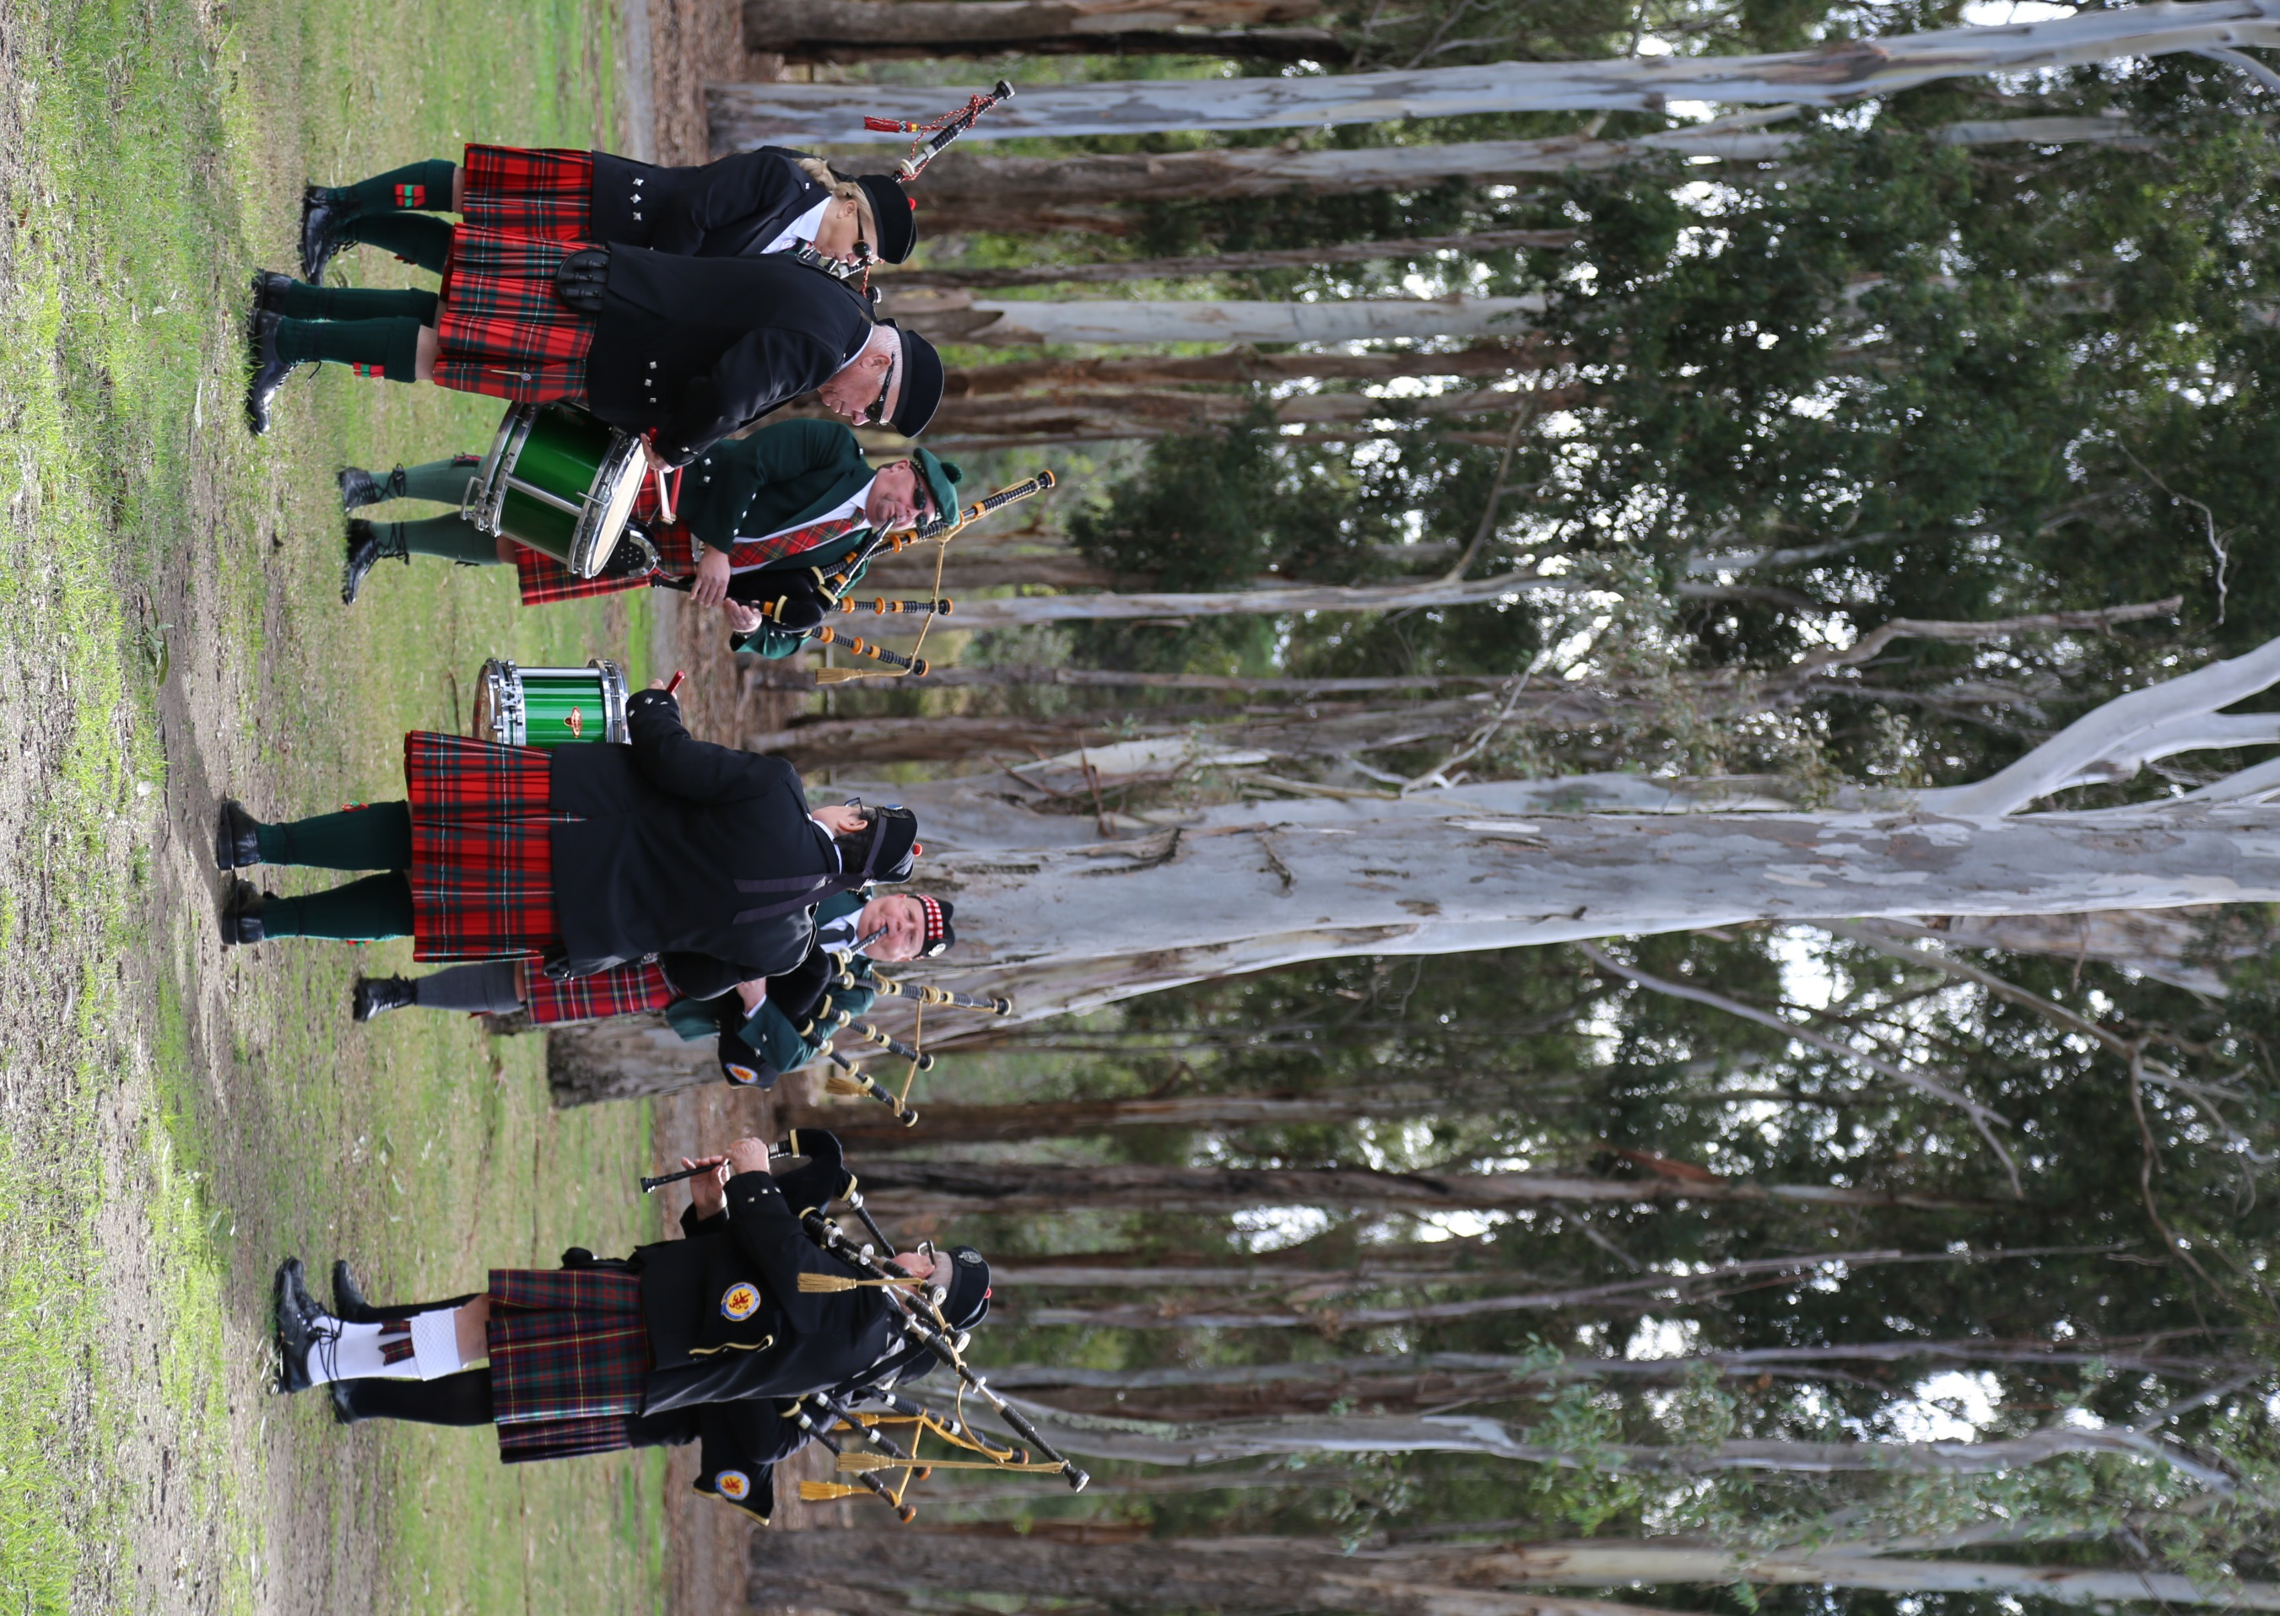
18th Annual

Scottish Heritage Day

Sunday 30th May, 2021

10.00am – 3.00pm

Unfortunately, due to COVID restrictions this day is for animal exhibitors and event organisers only.

FREE admittance and car parking
Dandenong Showgrounds, Greaves Reserve, Bennet Street, Dandenong. (Map ref: 90 A6/7)

Featuring: (classes commence 10am – late entries taken from 8am)

- Clydesdale classes: Foals & Mares
Enquiries to: Graeme Marriott gralynmarriott@gmail.com
- Shetland, Highland & Aust. Mini Ponies
Enquiries to: Jayne Stuchbery jaynestuchbery@bigpond.com
- APSB Victoria Foal Show
Enquiries to: Kym Robinson 0409 923 396 (after hours)
- Scottish Terrier Club:
Enquiries to: Dorothy Mitchell dottymit@gmail.com

all Competition to break for lunch 12-1pm

Champion of Champions Parade 2.00pm
(All Supreme Champions qualify)

Schedule of classes and General Enquiries: www.dandyshow.com.au (from 16th April)

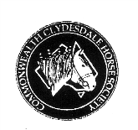
Thank you to our major sponsors including:

Scottish Heritage Day
SUNDAY 30th MAY 2021

Entry Fee $5.00 (inc. GST)
Entries close 21st May
Registrations:
All exhibits must be registered with a recognized breed Society.

All entries to: P O Box 362, Dandenong. 3175
Enquiries: refer cover page

PARKING AT RINGSIDE
ALL RINGS TO START AT 10AM
Ribbons to 3rd place

CLYDESDALE CLASSES – Ring 1
Class 1 Colt Foal born before 1/11/20
Class 2 Colt Foal born 1/11/20 & after
Class 3 Filly Foal born before 1/11/20
Class 4 Filly Foal born 1/11/20 & after
CHAMPION FOAL-Rosette & Trophy donated by the Marriott Family and a Garland donated by The Follett Family.
RESERVE CHAMPION FOAL-Rosette & trophy donated in memory of Ray Marriott (classes 1-4 eligible )

Class 5 Unshod Foal
Class 6 Filly 1 year old
Class 7 Filly 2 year old
JUNIOR CHAMPION FEMALE-Rosette & Trophy Donated By Charles Bourke
RESERVE JUNIOR CHAMPION FEMALE-Rosette donated by Haylands Clydesdale Stud in memory of Hugh Barrie. (classes 6 & 7 eligible )

Class 8 Filly 3 year old
Class 9 Mare 4 year old & over
SENIOR CHAMPION FEMALE-Rosette
RESERVE SENIOR CHAMPION FEMALE-Rosette donated by Haylands Clydesdale Stud in memory of Hugh Barrie. (classes 8 & 9 eligible)

Class 10 Colt or Gelding 1 year old

SUPREME CHAMPION CLYDESDALE-Rosette; “THE BILL ANDREW AWARD”; plus an article donated by F & M LAWSON – Crofters Weaving Mill; plus Garland donated by Stan Fear and Family.
(Winners of championships & class 10 eligible)

Class 11 Foal by Australian Bred Sire (Sire to have been born in Australia)

Class 12 Novice handler (with foal bred by exhibitor)
(Novice not to have won a first prize at Scottish Heritage Day Foal Show)

Class 13 Junior Handler 10-16 years –
Rosettes to third place

Class 14 Youth Handler 17-21 years
Rosettes to third place.

Handler Classes sponsored by A & Y Clarke

Class 15 Pair of Foals owned by exhibitor
Class 16 Pair of Foals by the Same Sire
Class 17 Mare and One of Her Progeny

PART BRED CLYDESDALES (50%-either Sire or Dam is to be CCHS registered Clydesdale)
Enhancing the qualities of the Clydesdale breed and providing an opportunity for those exhibitors that choose to cross breed for increased versatility.
Class 18 Best Foal- Colt or Filly
Class 19 Yearling – Colt or Filly
Class 20 Best Female – 2 years & over
Class 21 Best Gelding – 1 year and over

BEST PART BRED EXHIBIT – Rosette

Garlands made by Lyn Millburn Garlands.

SHETLAND PONY CLASSES – Ring 2
Class 27 Mare 4 years & over
Class 28 Filly 3 years
Class 29 Filly 2 years
Class 30 Filly yearling

CHAMPION SHETLAND FEMALE -Rosette
RESERVE CHAMPION SHETLAND FEMALE-Rosette

Class 31 Gelding 4 years & over
Class 32 Gelding 3 years
Class 33 Gelding 2 years
Class 34 Gelding yearling

CHAMPION SHETLAND MALE – Rosette
RESERVE CHAMPION SHETLAND MALE - Rosette

Class 35 Led Mare, Filly or Gelding most suitable for a child. Led by a child 6 years & under
Class 36 Led Mare Filly or Gelding most suitable for a child. Led by a child 7-15yrs

BEST CHILD’S PONY-Rosette

Class 37 Child Handler 6 years & under
Class 38 Child Handler 7 years-10 years
Class 39 Child Handler 11 years-17 years

BEST CHILD HANDLER-Rosette

Class 40 Shetland Pony Mare or Gelding in harness.
JUDGED AT 11.45am in AMPS ring – (all competitors must wear hard hats)

BEST HARNESS PONY from classes 90 & 40
(Shetland and Australian Miniature Pony)

LUNCH BREAK ALL rings close 12-1pm.

Class 41 Ridden Shetland Pony Mare
Class 42 Ridden Shetland Pony Gelding
Class 43 Shetland Pony- handler in traditional Scottish dress

Class 44 Fancy Dress

FOAL CLASSES:
Foals born after 31/7/20
Class 45 Shetland Pony Filly Foal not over 7.2hh
Class 46 Shetland Pony Male Foal not over 7.2hh

CHAMPION FOAL NOT OVER 7.2HANDS-Rosette
RESERVE CHAMPION FOAL NOT OVER 7.2HANDS-Rosette

Class 47 Shetland Pony Filly Foal over 7.2hh
Class 48 Shetland Pony Male Foal over 7.2hh

CHAMPION FOAL OVER 7.2 HANDS-Rosette
RESERVE CHAMPION FOAL OVER 7.2HANDS - Rosette

SUPREME CHAMPION FOAL-Rosette
and Janal Trophy

SUPREME CHAMPION SHETLAND PONY EXHIBIT –Rosette
(Champion Shetland Pony and Supreme Champion Foal eligible )

Class 49 Pair of foals by the same sire
Class 50 Pair of foals bred by the exhibitor

HIGHLAND PONY CLASSES – to follow on after Shetlands.

Class 51 Highland Pony Foal – born after 1/8/2020
Class 52 Highland Pony Mare
Class 53 Highland Pony Filly 1, 2 or 3 years

CHAMPION & RESERVE CHAMPION
HIGHLAND PONY MARE OR FILLY (Foal eligible if a filly)

Class 54 Highland Pony Gelding 4 years & over
Class 55 Highland Pony Gelding 1, 2 or 3 years

CHAMPION & RESERVE CHAMPION
HIGHLAND PONY GELDING

Class 56 Junior Handler
Class 57 Ridden Highland Pony
Class 58 Highland Pony -handler in traditional Highland Costume

SUPREME CHAMPION HIGHLAND PONY-Rosette

AUSTRALIAN MINIATURE PONY CLASSES - Ring 3

Class 59 Gelding yearling
Class 60 Filly yearling
Class 61 Colt yearling

CHAMPION YEARLING – Rosette
RESERVE CHAMPION YEARLING – Rosette

Class 62 Gelding 2 years
Class 63 Filly 2 years
Class 64 Colt 2 years

CHAMPION 2 YEAR OLD – Rosette
RESERVE CHAMPION 2 YEAR OLD – Rosette

Class 65 Gelding 3 years
Class 66 Filly 3 years
Class 67 Colt 3 years
Class 68 Mare 4 years & over
Class 69 Gelding 4 years & over

CHAMPION SENIOR– Rosette
RESERVE CHAMPION SENIOR – Rosette
SUPREME YOUNG STOCK – Rosette

Foals born 1st August 2019 to 31st October 2020
Class 70 Male Foal
Class 71 Filly Foal
Foals born 1st November 2019 onwards
Class 72 Male Foal
Class 73 Filly Foal

CHAMPION FILLY FOAL-Rosette
RESERVE CHAMPION FILLY FOAL-Rosette
CHAMPION MALE FOAL-Rosette
RESERVE CHAMPION MALE FOAL-Rosette

SUPREME CHAMPION FOAL-Rosette & Perpetual Trophy Donated By Victorian Members Of The Australian Miniature Pony Society plus
Garland donated by Haylan Shetland and Miniature Stud.

CHAMPION OF CHAMPIONS
Winner receives Rosette plus
Alex Morgan Memorial Trophy donated by the Morgan Family
ALL SUPREME CHAMPIONS ARE REQUIRED TO PARADE AT 2.00 PM

ALL following classes are open to all miniature ponies.
Class 74 Dual registered male
Class 75 Dual registered female
Class 76 Two ponies from one mare
Class 77 Two ponies by one stallion
Class 78 Two ponies bred by owner
Class 79 A pair of ponies

COLOUR CLASSES
Class 80 Broken Coloured Pony
Class 81 Dilute Pony
Class 82 Spotted Pony
Class 83 Black Foal
Class 84 Any Other Colour Pony

BEST COLOURED PONY - Rosette

CHILD HANDLER CLASSES
Class 85 6 years & Under
Class 86 7 years to 10 years
Class 87 11 years to 17 years
Class 88 Mare, Filly or gelding, appendix
Registered led by a child

BEST CHILD HANDLER – Rosette

Class 89 Pony - handler in traditional Highland Costume

Class 90 Australian Miniature pony mare or gelding in harness
TO BE JUDGED AT 11.45AM (All competitors must wear hard hats)

